Create Node-RED Service:

1.To create a web application create a Node-RED service.

Steps:

1. Navigated to the App creation page

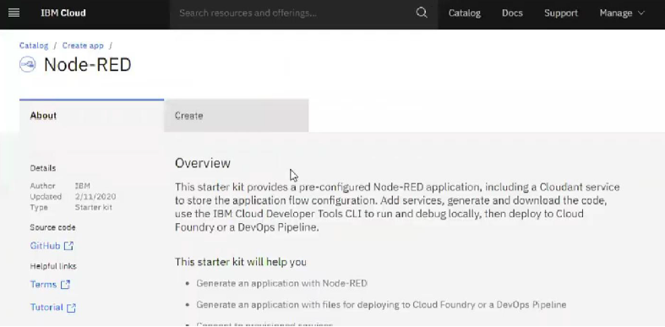

1. Enter project details and click on create

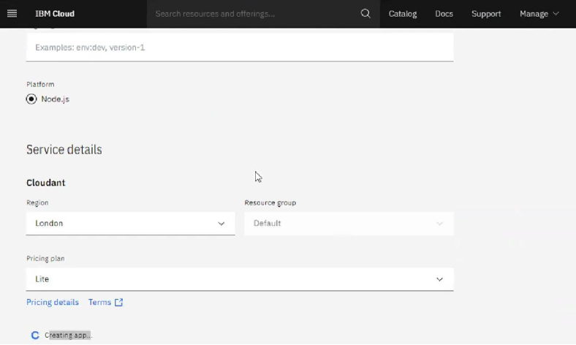

1. Click on the “Deploy your App” Button

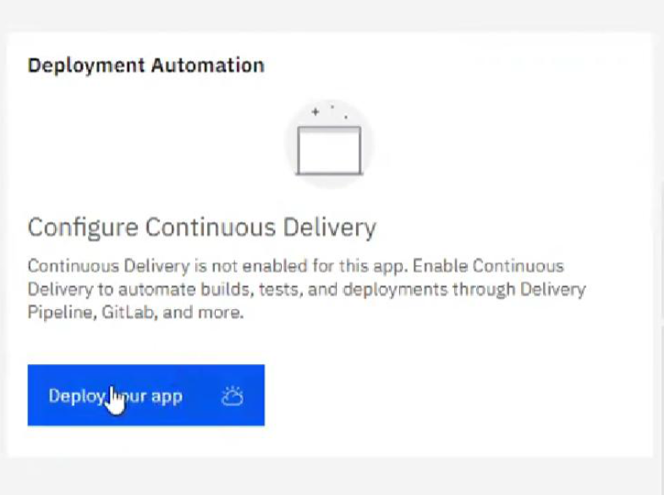

1. Set up the environment and deploy the app

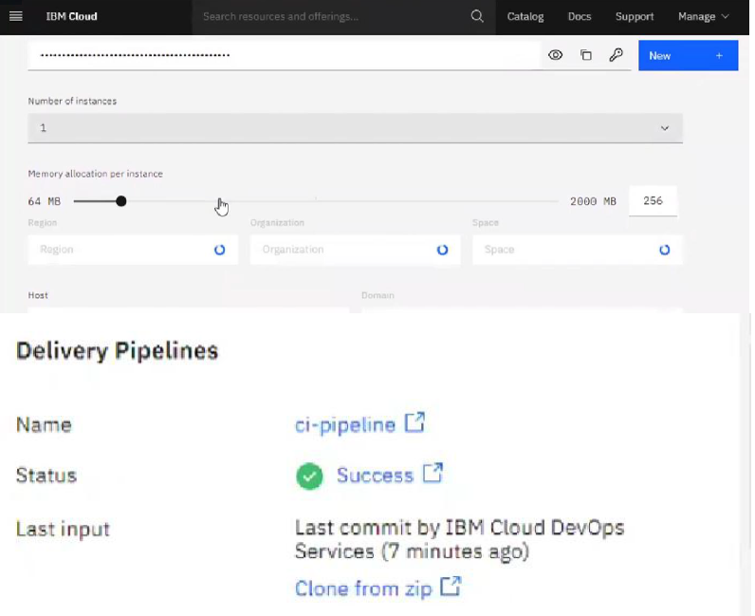

1. Instance editor and set up credentials

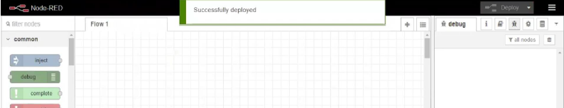

1. Drag and drop components into the editor

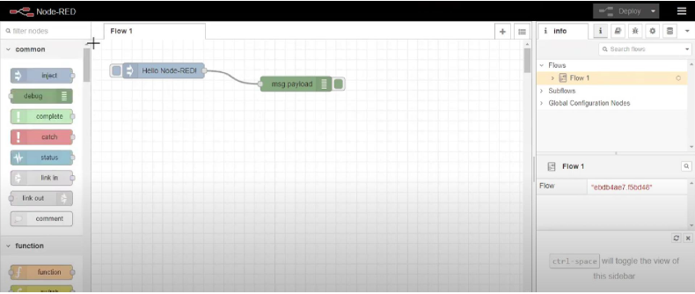

1. Deployed the app



**CONCLUSION:**

Created a NodeRED service on IBM Cloud Successfully.